Date: September 4, 2025
Ab Logistic Regression: this is for classification problem
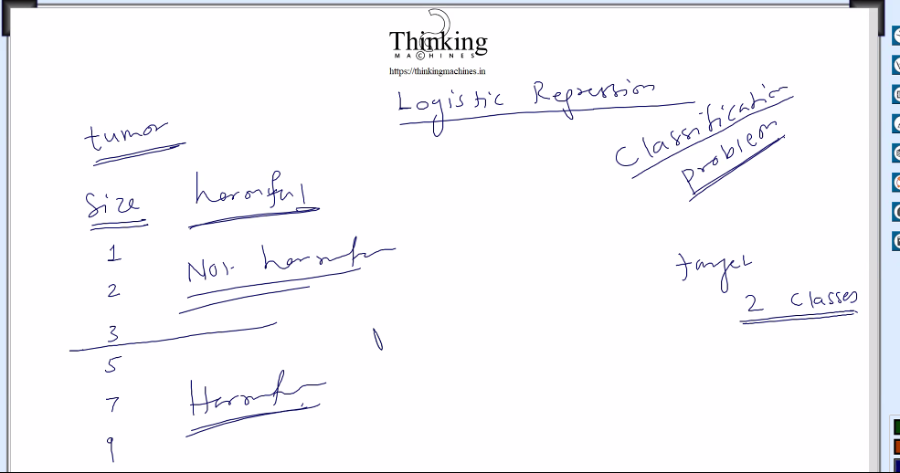
Trainging k baad humare model ko btana hoga ki tumor harmful he ki nahi
Ye 2 classes wala tarika use kr k 6 clasess ka kaam bhi ho jayega
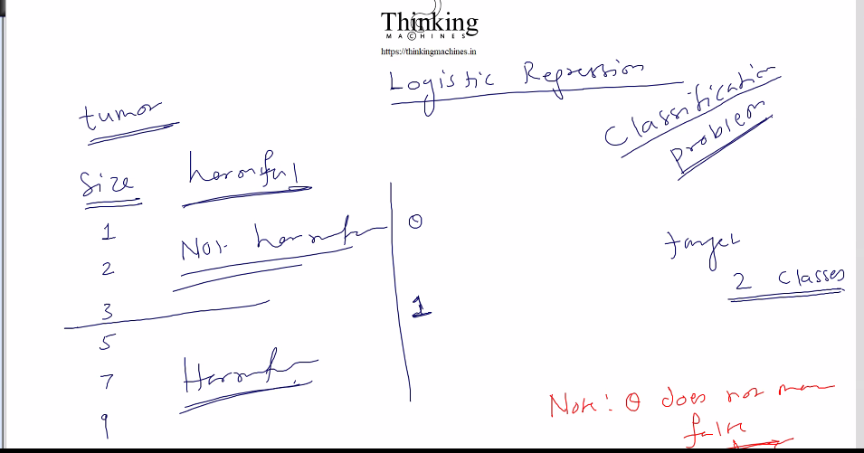
Tumor ko 2 class me divide kiya.
Data ko 2 class me devide kiya harmful and non harmful
Ek class ko 0 se and dusri ko 1 se represent krege.

Jisko predict kr rahe he usko hypothesis bolte he.
Linear regression k case me hypothesis function:
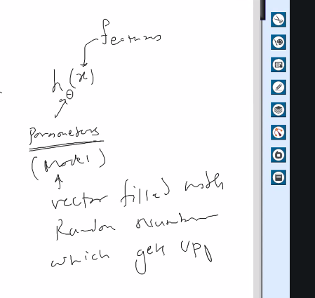
H theta x
H hypothesis function
0 theta : parameter , we can say model here
X: fetatures.
So linear regression k case me humara function tha X * Theta [X is feature matrix/ input matrix, Theta is model vector]
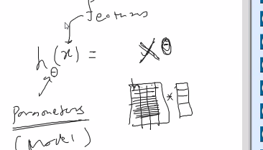

To isi ko bolege hypothesis function: derivatives ki theory apply kr k humne model ko update kiya tha in linear regression , model vector updataed during back propagassion using derivative theory.
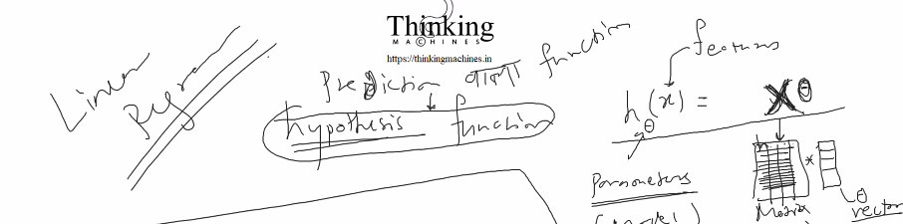

Linear reg me line fit wali baat thi.
Ab tumor ki baat krte he:
Y axis pr size,and x axis pr target [for harmful and non harful] ya ulta bhi kr skte he
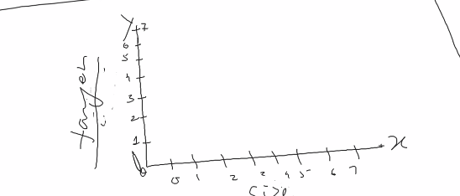
1,2,3 k liye non harmful means 0
4,5,6,…. K liye armful mtlb 1.
To y axis 0 and 1 me divide ho jayega.
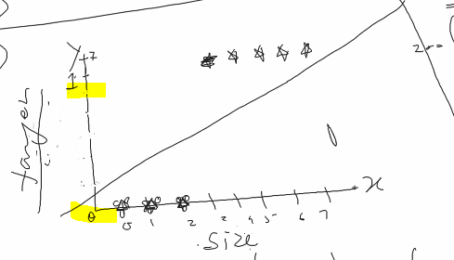
Ab ye 200 tk pahuch gaya to line fit nahi ho skti.
We wan predicted value between 0 and 1 for classificaition
Galat classify kiya to penalty heavy hogi
So hypothesis function X*Theta nahi ho skta
So this hypothetical function X*Theta will not work for classification problem
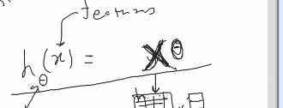
Humara hypothesis function X theta nahi ho skta.
Above .5 to 1, below .5 to 0 and accordingly penalty compute hogi and model update hoga.
Humko chahiye 0 ya 1 but humare math se 0 ya 1 nahi aa skta , to hum esa krege Above .5 to 1, below .5 to 0
Pr Xtheta ki value 0 and 1 k bich ki hogi iski guarantee nahi he, that’s why we said ye function humare case me kaam nahi krega.

So logistic regression k case me[Gradient desent ] k case me function hoga, Xtheera ko sigmoid me wrap krna
Xtheeta k result pr sigmoid apply kr dege
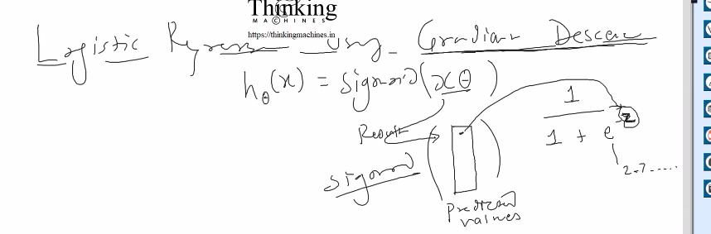

Z= predicted value
E= napiers constant
E ki power Z nikalne k liye power function use krege.
Cose function ab mse nahi ho skta.

Ab humare paas input matrix X he.
And ek random model vector Theta
Multiply kr k predicted value aayegi.
Is predicted values pr sigmoid apply krege.
Jitney training example utni predicted values.
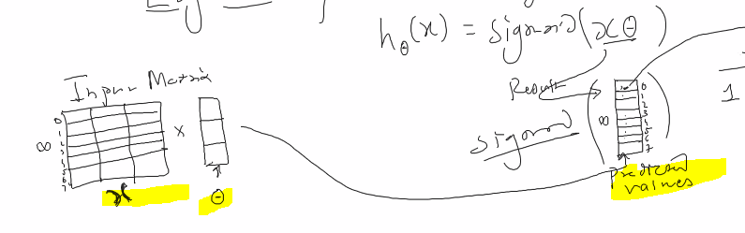
Sigmoind humne predicted value ko 0 and 1 k bich me lane k liye lagaya he
Sigmoid ka graph:
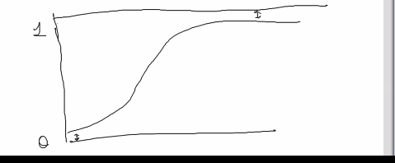
Sigmoid ka graph: 0 and 1 k bich me hi rahega , kabhi bhi 0 and 1 ko touch nahi krega.
Max cases me classification problem hi rahegii. Bs number or clasess jyaga hogi
Iske baad neural network , phir deep learning.

Training ki process kya he:
10 saal ka exp he pr unko ml/ai me jaana he.
Family+company : time nahi bchega. Bachelor k liye sahi he ye course.
India me iska koi work dekhne k liye nahi milega.
Interview java ka pr sawal springboot k, and baate securities ki
Starter se sb configure kr k maven build .
Ese hi jb ml/ai k interview ki baar aati he , to hum jo kr rahe he usko justify krna mushkil he.

Theory full and practical then python pr jump.
And then uski library rat lo. Udr code nahi likhna he udr sb library bani he.

End of the day model.
Ek saal ho gaya ek line ka bhi code nahi likha,
Tool ka use,
Data ikkatha krna , scaling krna , bad data hatana[ bani bani script ya formula in excel]

Training k liye kya tarika:
Loop for no. of iteration
- Hypothesis function apply krna
- Cost compute krna linear me MSE
- Model update [ya update parameteres]
Ab logistic ki baat kre to hypothesis function
- Hypothesis function apply krna : simoid of Xtheta
- Cost compute krna losgistic me Binary cross entropy
- Model update [ya update parameteres]
To update krne ka tarika bhi bdlega, kyuki derivative jo nikla vo alag tarike ka hoga.

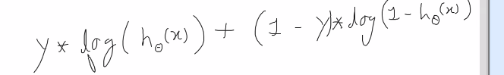

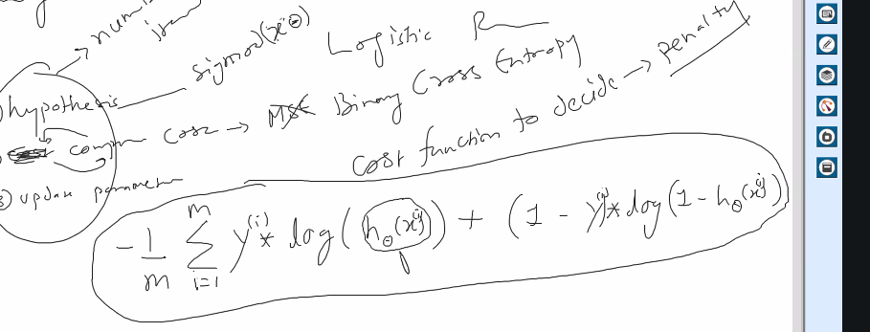
Ye he cost function: which tells the penalty
HTheeta is predicted value.
I represent 1 training example

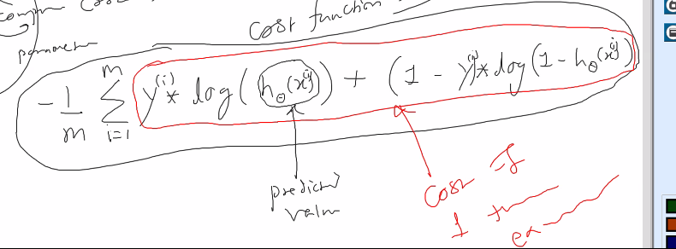
Ye red wale ka jo result aayega usko cost of 1 training example bolege.
Apne naam se website: samne wala dataset file upload kr skte. Size restricted kr k.
And ye sb dikha ske.
Server side pr koi sib hi technology lo , c ki executable invoke krna he.

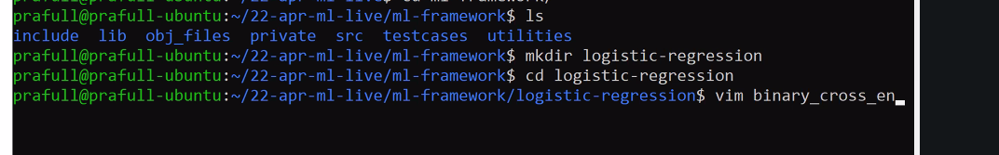
Start krte he:
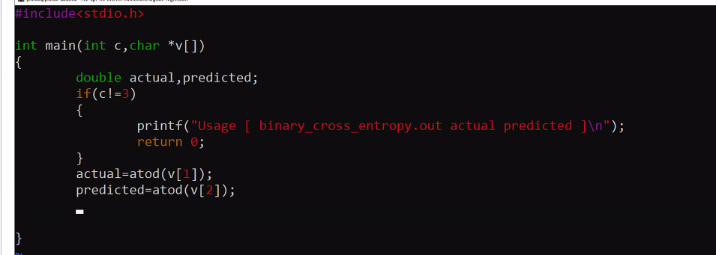
Predicted mtlb 0 and 1 k bich
Atod ko jagah strtod
atoi , atod, atof, strtod, linux main page ye search krna gpt pr and strtod smjhana he sir ko.
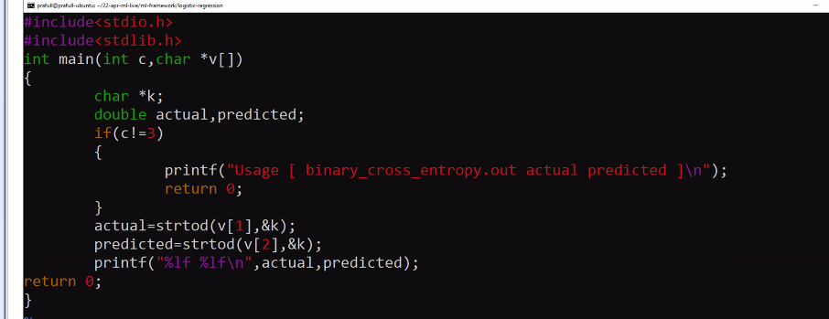

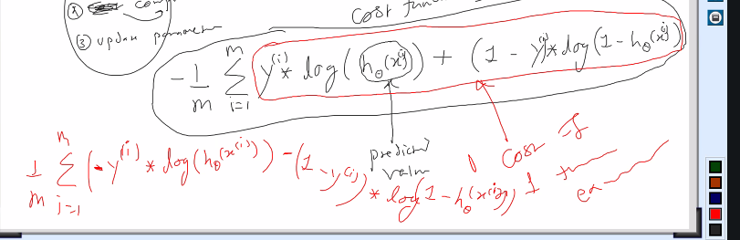
1 example k liye formula bdlega , vo – ko andr le gaye.
Ek program bnate he is formula ko test krne ke liye.
Ye bna bnaya he.
Ye dono golo ko programetically ese break kiya
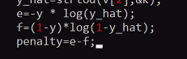
Log function math.h se
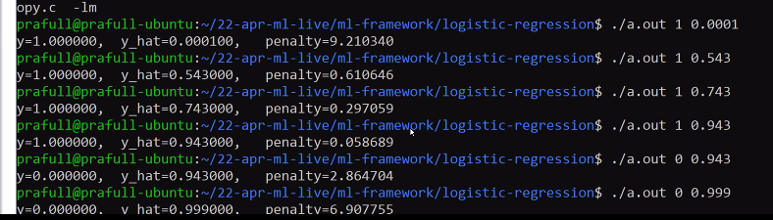
Cost function se penalty aa rahi he.
Cost function esa kyu, ye research hum nahi kr skte,
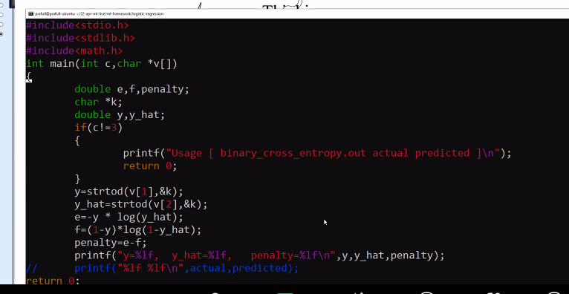
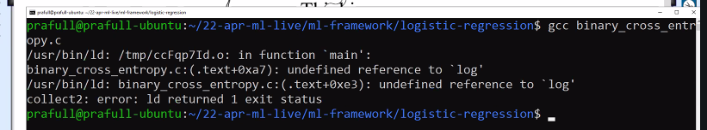
Math.h ko include krna pdega.
Hum bhi prototype likh skte he header file include krna jaruri nahi he.
But humne prototype galat likh diya , code compile ho jayega pr aage atak jayega.
Math ko include krne k baat prototype mil jayega, but definition nahi mil rahi to uske liye library ka naam btana pdega. Us lib ka naam he m
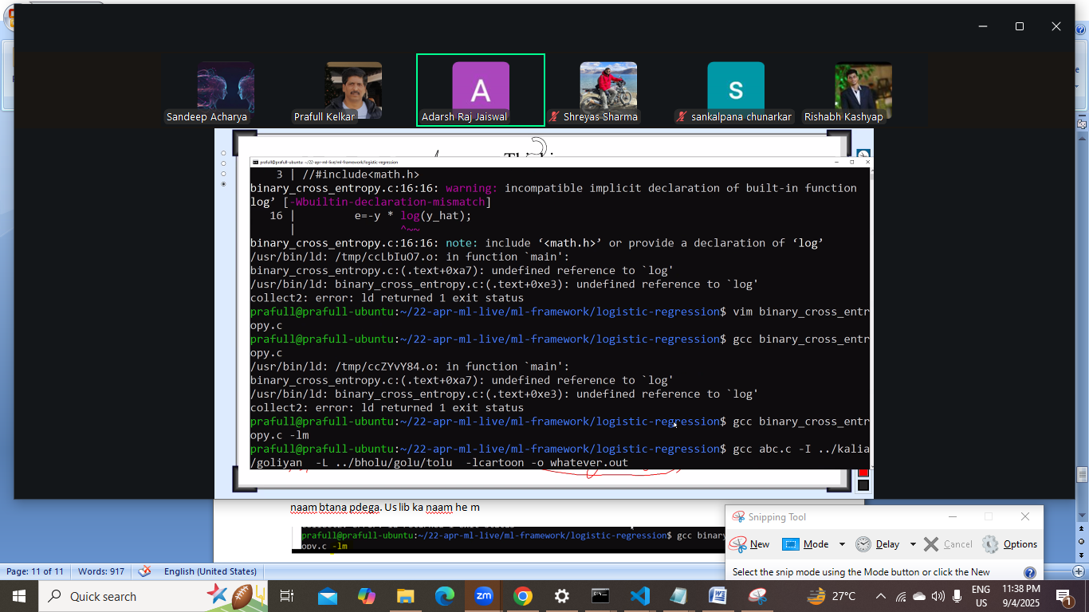
-I se header file kidr milege ki
-L se ye btaya ki library file kaha milegi
-l se bta rahe he ki lib file ka naam kya hoga
-lm k case me –L nahi diya kyuki usko pta he ki lib file kaha he.
libm.a
ubuntu generally servers k liye nahi rahta,
server k liye sentos ya pese he to redhat.

Next session update parameter wali baat.

Date: September 6 2025-09-06. September 6 09/06

Apna hyposthesis function kya he.
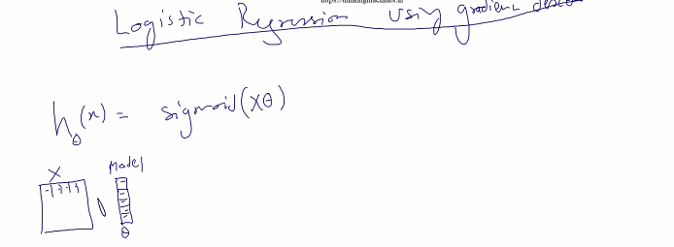
X k column and model k row are equal. Result vector aayega
Ab sigmoid function bnana pdega.
Sigmoid function available nahi he.
Sigmoid vector lega and ek vector dega. Ye ho gaya predict krne wali baat
Next: cost function compute krna
Pure vector k hisaab se sochege. : sbke liye krege to – ko bahar le aayege
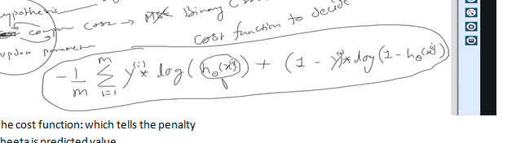
Ab iske liye kya kya infrastructure chahiye
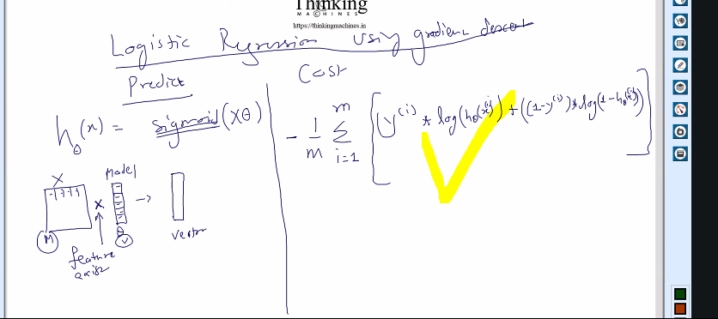

Sigmoid vector lega vector dega : ye he
Vo vector log dega and log nikal k again vector dega. Ye lagegi
Us vector ka Y(i) k sath multiply ye lagegi. [element wise vector multilication](vector,vector) lega and vector dega.
Ye required functionalities
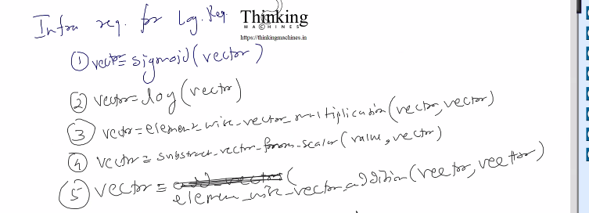

Ab ispe 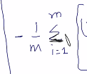 apply krna , is se scalar value aayegi . us pe 1/m se multiply.
Final:
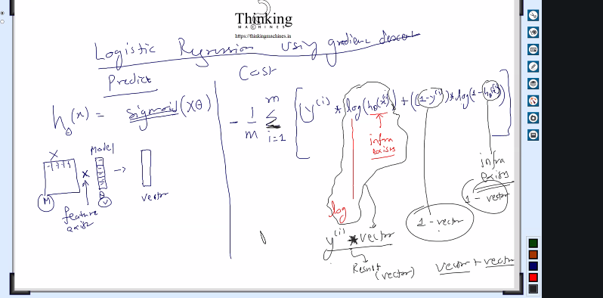
Required infra:
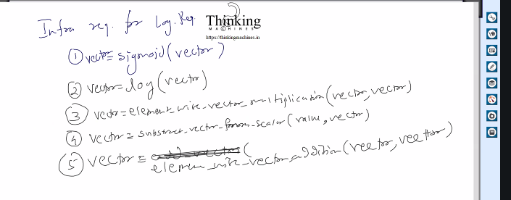

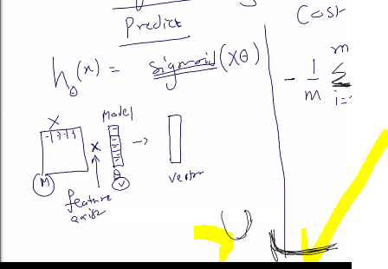
Isko convecx function bolte he, humare case me graph ye right wala bnega.

Next: Update rule for logistic, updte rule kiske bharose nikal jayega[derivative wrt what is affecting the class] model ki value, with respect to theta.

Internet use nahi krna

Kyuki future me kuch esi chiz aayegi vo internet pr nahi milega
Kuch search nahi krna he.
Formula and dericvative ki theory he.

Definition: linear regression using normal equation
Abhi , data he model he and update theta ,
Phir predict
Normal equation kr k kuch he, us se iteration k bina ek shot me kaam ho jayega., iske liye phir se infra ready krna h.
Kyu normal equation implement krne me bahut saara time lgega.
Time lgega isliye ye iteration wala tarika use kr rahe he and normal equation wala use nahi kr rahe he , ya reason kuch or hoga.’

Normal equation k bare me chatgpt se:
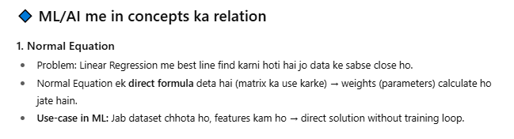
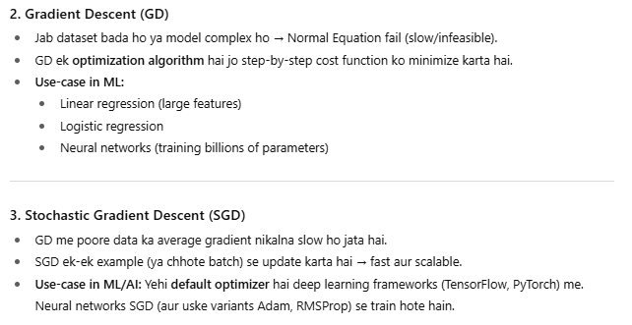
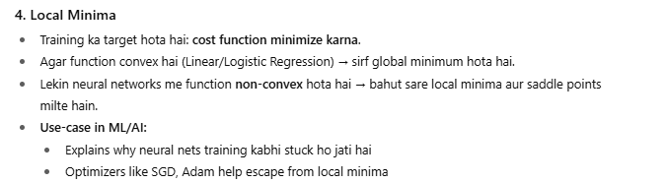
VIMP thing:
